Xceleration Media™ Chooses FastLane Metalworx to Create Editor’s Choice Awards

Memphis, TN – Xceleration Media Group® (XM) announced that FastLane Metalworx will once again make all its awards for the 2017 car show season, including its coveted Editor’s Choice award. The Editor’s Choice award is given out at select events throughout the year, including the Street Machine Nationals in Du Quoin, Illinois, and St. Paul, Minnesota.

FastLane Metalworx is a veteran-owned business that makes one-off custom CNC-machined steel works of art at its Lacey Springs, Alabama, shop. Using 12-gauge cold roll steel, owner Mark Kennemer and his team can create just about any type of sign or wall hanging. The XM Editor’s Choice Awards are two-dimensional wall hangings utilizing layered pieces of steel, along with paint and clear coat, to create an almost three-dimensional effect. FastLane Metalworx has created an award for each of the three XM street titles: Gearheads4Life, Street Rod Life, and Power and Performance News that match the logo for each and include the words “Editor’s Choice” underneath.

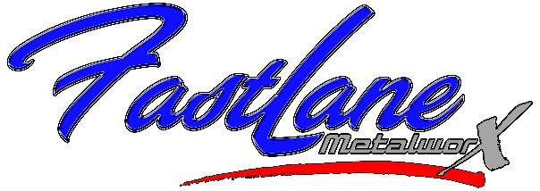
“FastLane Metalworx has been with us since the beginning, and I’m so glad we are continuing our growth together,” XM Operations Director Shawn Brereton said. “Mark and his group knock it out of the park on every award they cut. Each one is a little bit different due to the paint and treatment to the metal. These awards have become very prestigious to receive. They are not cheap, quick to make, or very lightweight, so we are very select about where and when we give them, and I think that adds to the exclusivity of receiving one.”

Kennemer was glad to continue the relationship as well.

“We’ve been cutting the XM awards for three years now,” he said. “In that time, we have outgrown our original building and have added other offerings such as laser engraving and powder coating. We used the XM awards as examples of what we could do for other companies. We love seeing the pictures and getting the news of how much the recipients enjoy receiving them. I think I speak for both XM and FastLane when I say it is an honor to be able to give someone a handcrafted piece of art as recognition for all of the hard work and dedication they put into building their car.”

Xceleration Media™ editors attend hundreds of events each year, so make sure you check StreetRodLife.com, PPNDigital.com, and Gearheads4Life.com to see where they will be next. You never know; you could be the next person to receive the coveted “Editor’s Choice” award.

+++++

About FastLane Metalworx
FastLane Metalworx is a veteran-owned small business making custom CNC-machined metal art, signs, and logos. Located in Lacey Springs, Alabama, owner Mark Kennemer is a graphic designer who can design, cut, and paint/powder coat anything on metal and specializes in military logos and Americana. FastLane’s motto is “Bringing Your Ideas to Metal.” Visit fastlanemetalworx.com to see some of the latest creations or call 256.520.8140 to see what FastLane can do for you.

About Xceleration Media™
Xceleration Media™ is an automotive focused, multi-channel relationship marketing company at the forefront of today’s changing media landscape. With properties in five major automotive/motorsports segments, Xceleration Media™ uses a variety of innovative delivery channels to ensure its hard-hitting technical content reaches high-value enthusiasts, racers and hobbyists. Also visit us online at xcelerationmedia.com or on YouTube at youtube.com/xcelerationmedia.

Media Contact: sales@xcelerationmedia.com, 901-260-5910

